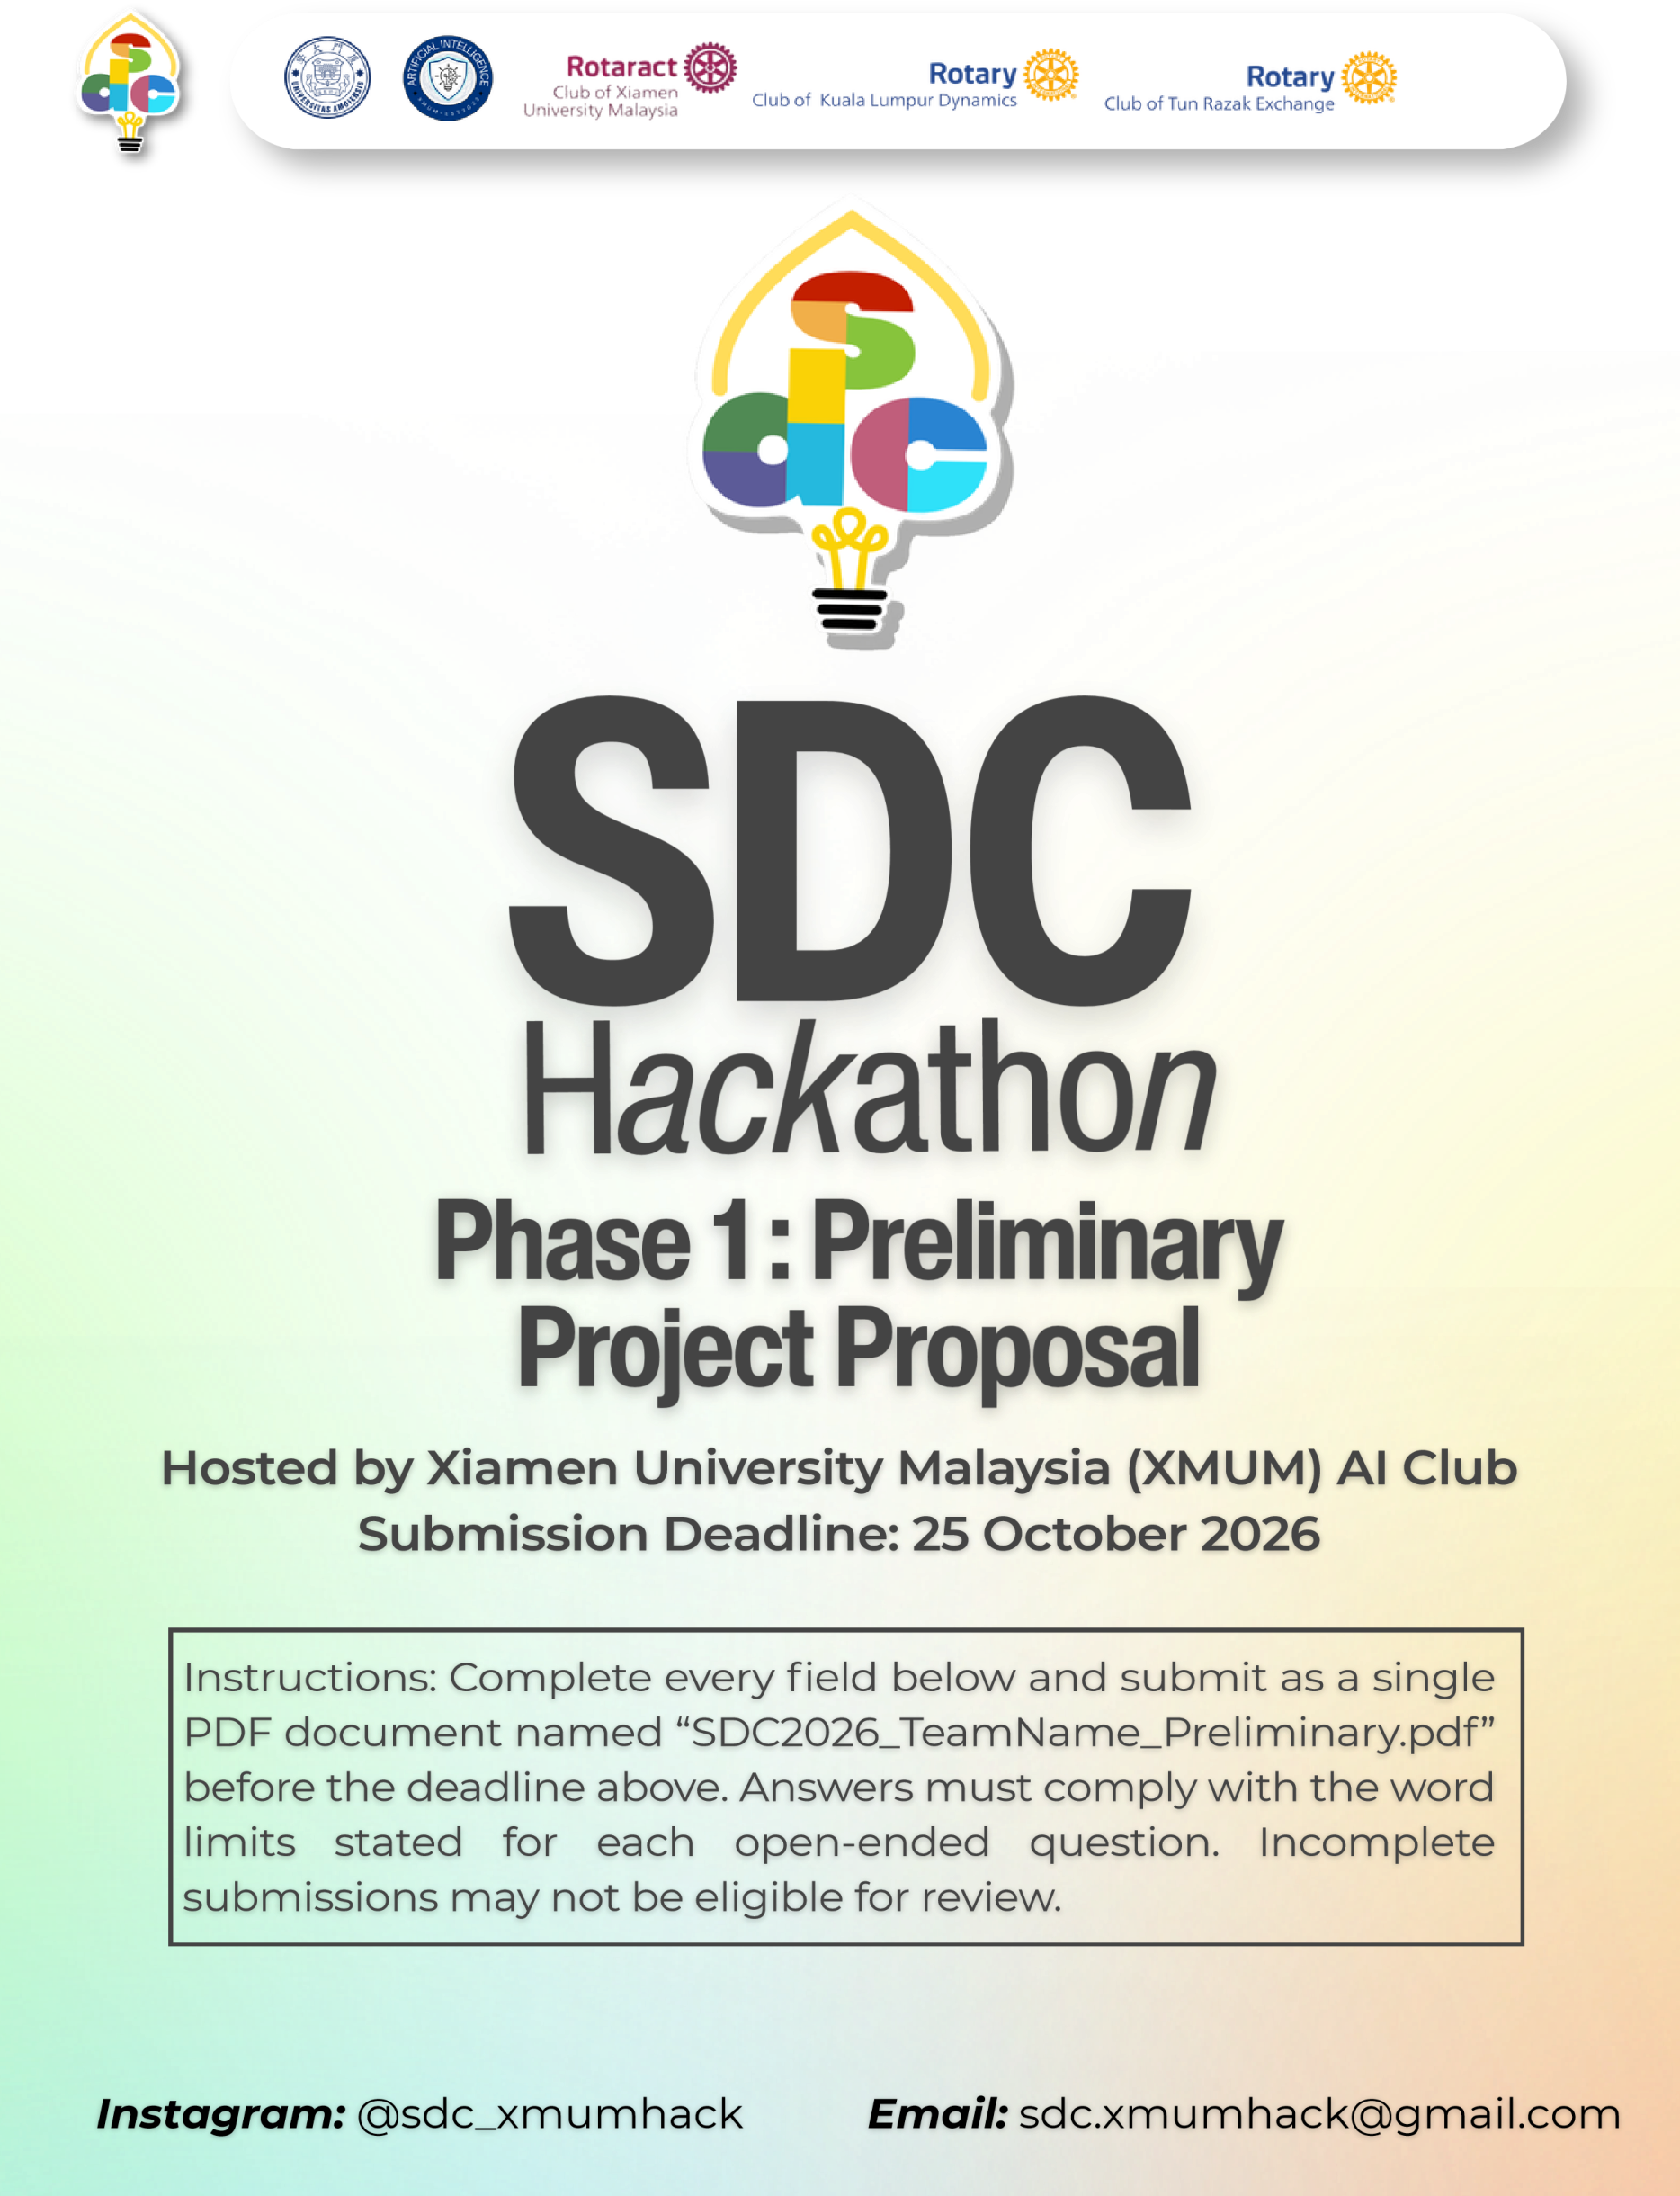
SDC HACKATHON 2026
Phase 1: Preliminary Project Proposal
Hosted by Xiamen University Malaysia (XMUM) AI Club
Submission Deadline: 25 October 2026
Instructions: Complete every field below and submit as a single PDF document named “SDC2026_TeamName_Preliminary.pdf” before the deadline above. Answers must comply with the word limits stated for each open-ended question. Incomplete submissions may not be eligible for review.

1. Team & Project Overview
Team Name | XYZQ Labs

Selected Domain | Domain 1

Selected SDG Track (1–17) | SDG 4, SDG 8, SDG 10

Project / Solution Name | Future Ready

Name (Leader) | Yi Hongyu

Email & Phone (Leader) | Eng2409018@xmu.edu.my

University Affiliation(s) | Xiamen University Malaysia

Number of Team Members | 4

2. Executive Summary & Problem Statement

2.1 The Problem Context
Describe the specific, real-world challenge your team is tackling. Who is affected by this problem, and why does it matter? Highlight the critical social, environmental, or economic issues involved.
[Maximum 250 words]
AI is changing the tasks and skills required across many occupations, while career guidance, job-market information, and affordable learning options are often spread across different sources. Working adults whose roles are changing, recent graduates, and career switchers can struggle to see how their existing experience transfers to emerging roles or which skills to build next. This can lead to costly or poorly targeted training decisions and make career transitions harder, especially for people with limited access to personalized guidance. Employers, educators, and career services also need clearer ways to discuss changing skill needs without treating uncertain forecasts as guarantees. FutureReady addresses this information and navigation gap. It is a career-exploration aid: it helps people compare skills, roles, evidence, and learning options, while leaving decisions about training and employment to the person and their advisers.

2.2 The Proposed AI Solution
Provide a high-level overview of your proposed application. How does it apply artificial intelligence to solve the problem stated above? Briefly mention the tools or technical skills gained from the SDC Phase 1 workshops (e.g., GenAI APIs, database architecture, cloud hosting) that you intend to leverage.
[Maximum 300 words]
FutureReady is a bilingual web application that takes a user from a skills profile to explainable future-role suggestions and an ordered reskilling pathway. Users can explore with synthetic profiles in the public demo. In a properly provisioned local deployment, they can provide resume text or a text-based PDF/DOCX, review the extracted text, and confirm the skills used. The local matching workflow uses a pinned, quantized multilingual E5 model in ONNX format to compare profile text with a catalogue of 65 occupations; it reports similarity scores and skill gaps, not hiring probabilities. Dated job-market and research snapshots provide trend context, with visible sources and dates. The app also links roles and skills to SDGs, recommends learning resources, and compares moderate and faster-disruption scenarios. The prototype uses React, TypeScript, Vite, Python, FastAPI, OpenAPI, structured JSON/CSV data, GitHub version control and Actions, Docker, and Render hosting. The matching model is not a generative AI service. The current project does not use an official SDC sponsor-provided GenAI API or cloud platform.

3. Technical Architecture & Implementation Plan

3.1 Conceptual Tech Stack
List the technologies, frameworks, APIs, and databases you plan to use to build a functional, deployed prototype. Describe (or attach as an appendix) a simple system block diagram showing how the workshop elements connect into one architecture.
Did your project utilize any official SDC sponsor-provided GenAI API or Cloud Platform? If yes, specify which one and how it is used.
Frontend: React, TypeScript, and Vite.
API and application: Python, FastAPI, Uvicorn, and OpenAPI.
AI matching: The full local résumé workflow uses a quantized ONNX version of intfloat/multilingual-e5-small to generate text embeddings and calculate cosine similarity. The free Render demo supports synthetic profiles only and does not provide the full résumé-model workflow.
Data and storage: JSON and CSV files store job, skill, trend, source, course, scenario, and SDG data. The current version does not use a SQL database.
Build and deployment: Docker, GitHub Actions, and Render Free.
User
↓
React / TypeScript / Vite (profile entry and review)
↓
FastAPI application
↓
Matching and pathway logic ← Dated JSON/CSV role, trend, course, source, and SDG data
↑
Local E5 ONNX embeddings (full local résumé workflow only)
↓
Ranked roles, skill gaps, evidence, learning options, SDG links, and scenarios
SDC sponsor-provided services: The current prototype does not use an official SDC sponsor-provided GenAI API or cloud platform. Render is a third-party hosting provider. ChatGPT and Codex assisted with development and documentation only; the deployed application does not call either service for runtime matching.

3.2 Design-Thinking & Deployment Strategy
Explain how your team applied design-thinking methodology to ensure this solution is technically viable, user-friendly, and ready for real deployment by Phase 2.
[Maximum 200 words]
We shaped the prototype around the user journey in the project brief: describe current skills, understand changing opportunities, compare suitable roles, and choose a practical learning path. The interface explains match evidence, data sources and dates, skill gaps, SDG links, and scenario assumptions so users can question recommendations rather than treat them as decisions. Synthetic profiles support a privacy-conscious public demonstration; the local resume workflow includes text review and user confirmation before matching. Technical feasibility is supported by the working web/API architecture, repository automation, and a hosted synthetic demo. Before deploying resume analysis for real users, Phase 2 should test usability and accessibility with intended users, review privacy and data-retention controls, validate data rights and source freshness, and evaluate recommendation quality and potential bias. No formal user study, fairness assessment, or employment-impact measurement has yet been completed.

4. Preliminary Environmental & SDG Impact Framework
To align with SDC’s focus on meaningful global sustainability, establish your project’s impact baseline before building the prototype. Use estimated data, published research, or public benchmarks where exact figures are unavailable. Provide the citation of any sources used.
The target, baseline, and KPI you provide here will be used by judges during shortlisting to assess Innovation and Creativity as well as Feasibility of build. Vague or unsupported projections may weaken your case for advancing to Phase 2.

Metric Category | Your Response
Target SDG Sub-Target(s)  Identify the exact UN SDG sub-target your project addresses  e.g., Target 11.6 “Reduce the adverse per-capita environmental impact of cities, focusing on air quality and waste management.” | SDG 4, Target 4.4 — increase the number of youth and adults with skills relevant to employment, decent work, and entrepreneurship. Supporting: SDG 8, Target 8.5 — advance full and productive employment and decent work for all. FutureReady supports career exploration and skills planning; it does not claim to create jobs or guarantee employment. UN SDG 4, UN SDG 8
Current Problem Baseline  What is the starting condition of the problem, expressed as a number?  e.g., “The target infrastructure currently experiences 35% energy inefficiency due to unoptimized scheduling.” | The World Economic Forum’s 2025 employer survey found that 63% of surveyed employers identified skills gaps as a major barrier to business transformation. Employers also expect 39% of workers’ core skills to change by 2030. These are global employer expectations, not Malaysia-specific worker outcomes. FutureReady has not yet measured its own user baseline; the Phase 2 pilot will measure participants’ task performance before using the application. WEF, The Future of Jobs Report 2025: Skills Outlook, WEF, Workforce Strategies
Core Measurable KPI  The specific unit you will track  e.g., % reduction in power consumption, processing-latency improvement, or kg of resource waste avoided. | Percentage-point change in pilot participants who can complete a scored task: explain one recommended role, identify one relevant skill gap, and select one linked learning option. Use the same assessment before and after using FutureReady; report the number and percentage of participants who pass, plus completion time.
Phase 2 Impact Target  Your realistic, percentage-based target by the final prototype presentation  e.g., “20% improvement in computational resource use.” | In a small pilot of at least 10 consenting adult participants, achieve at least a 20-percentage-point improvement over the pre-use task pass rate and at least an 80% post-use pass rate. Treat this as an early career-navigation and usability measure, not evidence of improved employment or SDG outcomes.

5. Eligibility & Readiness Checklist
Tick all boxes that apply before submitting.
All team members have completed the mandatory GenAI, Database, and Cloud Deployment upskilling workshops.

The project concept addresses a verified real-world problem mapped directly to one or more UN SDGs.

The proposed solution targets a functional, deployed application rather than a theoretical business case study.

All fields in this template have been completed within the word limits stated.

6. IP & Originality Declaration
6.1 Pre-Existing / Prior-Owned Work
Does this submission include any code, design, research, or other work that any team member created or owned before the start of this hackathon?
☐ Yes ☐ No
If yes, briefly describe what was pre-existing and which team member(s) owned it:

6.2 Third-Party Code, Datasets, or Models
Does your project use any third-party code libraries, open-source frameworks, public/private datasets, or pre-trained AI models that your team did not create?
☐ Yes ☐ No
If yes, list them below (open-source use is permitted provided it is declared and properly licensed/attributed):
Name | Type (code/dataset/model) | License
React, TypeScript, Vite, FastAPI, Uvicorn, NumPy, ONNX Runtime, Tokenizers, and other locked dependencies | Open-source libraries and frameworks | Mixed licenses; each package retains its upstream license. See the project dependency manifests and lock files.
intfloat/multilingual-e5-small and pinned Xenova/multilingual-e5-small ONNX assets | Pre-trained embedding model | MIT; revision and asset hashes are recorded in docs/model-notice.md.
Department of Statistics Malaysia / data.gov.my skills-related labour-force data | Public dataset | CC BY 4.0, as recorded in the project attribution file; retain attribution.
O*NET, U.S. Bureau of Labor Statistics, TalentCorp MYCOL, Arbeitnow, and arXiv metadata | Occupational, forecast, job-posting, and research data | Source-specific terms apply. See artifacts/api-server/data-package/ATTRIBUTION_AND_USE.md; public access does not mean unrestricted redistribution.
Course-provider metadata and UN SDG references | Third-party metadata and reference material | Provider/source terms apply. The project stores selected metadata and links, not course content.
Project-supplied 65-role catalogue | Role and skills dataset | The upstream redistribution terms were not provided; confirm the catalogue owner’s license or permission before redistribution.

6.3 Employment-Related IP Conflicts
Is any team member currently bound by an employment, internship, or consulting agreement under which their employer could claim ownership of work they create during this hackathon?
☐ Yes ☐ No
If yes, please describe the nature of the agreement and which member it concerns:

7. Declaration
By submitting this proposal, the team leader confirms that the information provided is accurate to the best of the team’s knowledge and that the project will be original work created during the SDC 2026 hackathon period.

[Signature]
[Date]25/10/2026

